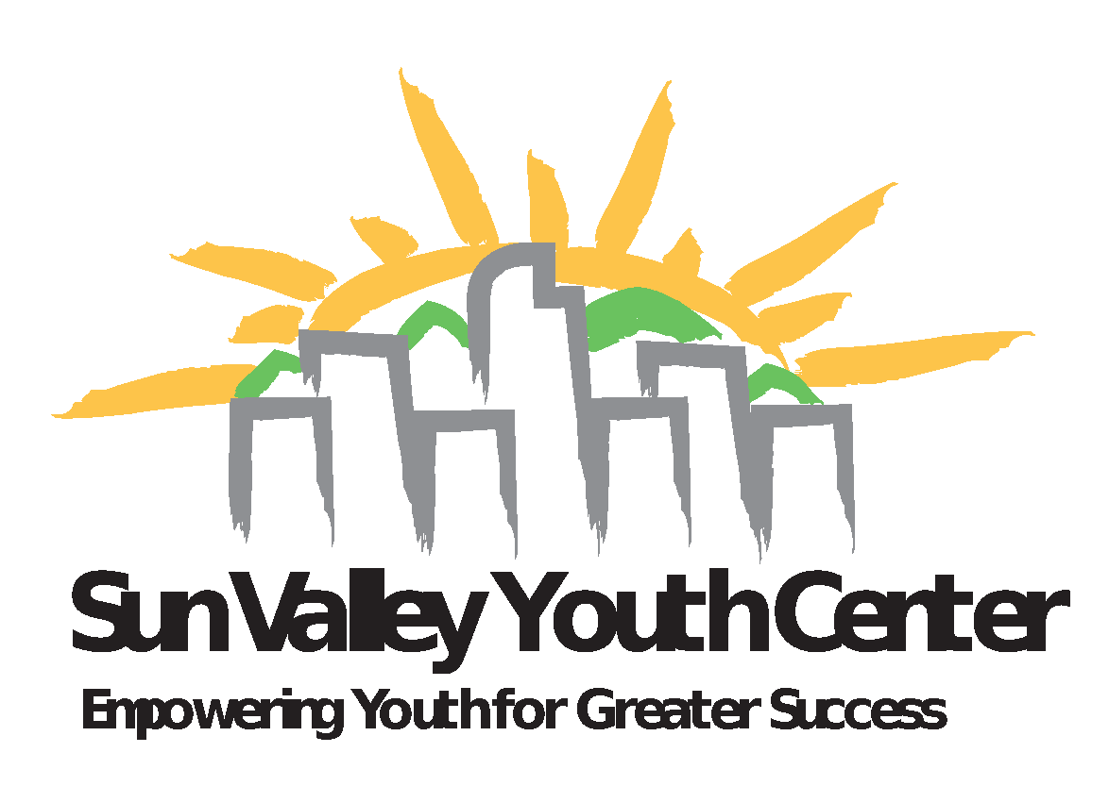

## Volunteer Application

### Name ________________________________Telephone Number __________________

Address ________________________________________________________________ Street City State Zip

Email Address:_________________________________ Date of Birth ______________

**In the case of emergency**,

I hereby check one:

do _____or do not _____ authorize an adult Sun Valley Youth Center person, as an agent for me, to consent to treatment and hospital care as advised by a physician, surgeon or dentist. I agree that if I do not have health coverage, I will be responsible for paying for this care. *I expect that the person designated below will be notified as soon as possible.

*Emergency Contact: __________________________________Phone:______________

If you have any health problems you feel we should be aware of, please explain below.

Previous Experience (if any) ________________________________________________

List Community Affiliation _________________________________________________

Please **list two** references relevant to the project:

1.________________________________________________________________________________

Name Number Email relationship

2. .________________________________________________________________________________

Name Number Email relationship

What language(s) other than English do you speak? ______________________________

Are you looking for service with youth or non-youth opportunities? _________________

How many hours per week are you available? __________________________________

What day(s) work best for you?______________________________________________

What are some of your gifts and skills?

What do you hope to gain from this experience?

Do you need credit for your service? ________________________________________

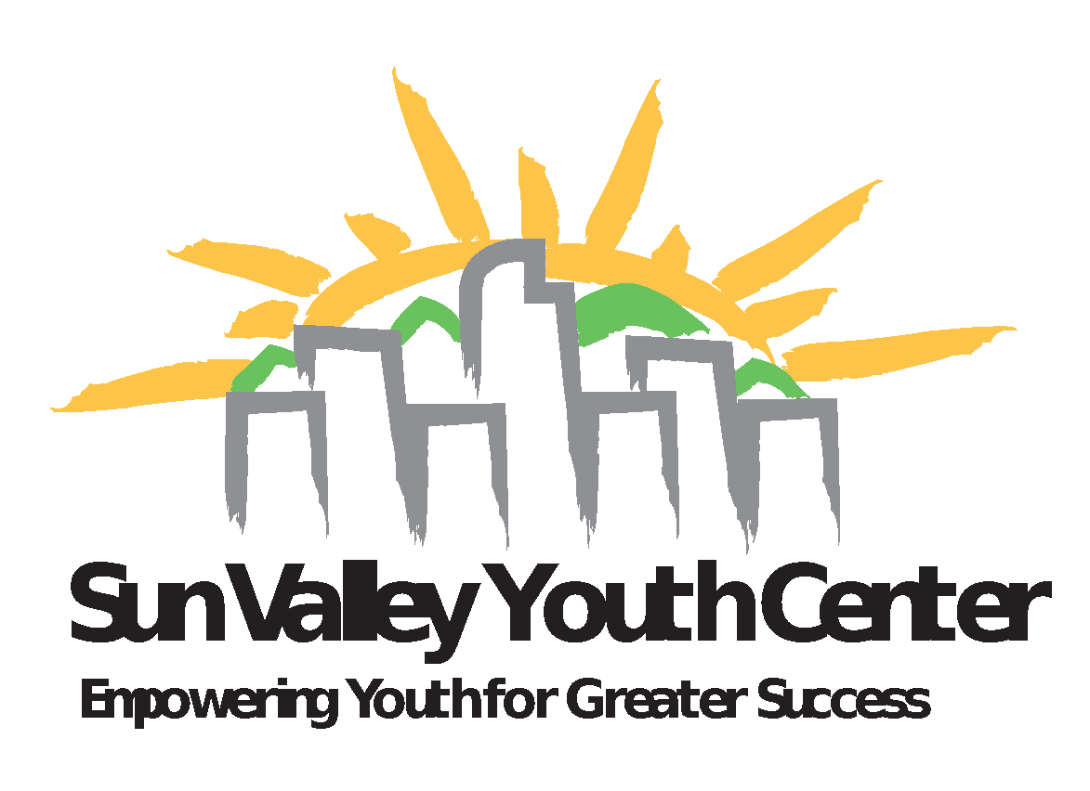

# Release of Information/Statement of Consent

*All Sun Valley Youth Center applicants will be subject to a background check.*

*Parental consent is absolutely necessary for persons under the age of 18.*

I, _______________________________, do hereby consent to the background investigation and authorize a review of all records, or any part thereof, concerning myself, by and to a duly authorized agent of the Department of Police and/or Public Safety and Correctional Services, whether the said records are public or private, and including those that may be deemed to be of a privileged or confidential nature. I understand that all of the information will be kept confidential. I also understand that should any statement I have made prove to be false, misleading or erroneous, it may result in rejection of my application or discharge from the program.

Name:________________________________________________(please Print)

Signature:___________________________________ Date: __________________

Guardian Signature if under the age of 18____________________________Date______

RETURN THIS FORM WITH THE APPLICATION AND THE FOLLOWING ITEMS

* SOCIAL SECURITY #__________________________________
* COPY OF DRIVER’S LICENSE OR
* BIRTH CERTIFICATE

Facility Name: Sun valley Youth Center License # 1522881

Perjury Statement:

“Any applicant who knowingly or willfully makes a false statement of any material fact or thing in the application is guilty of perjury in the second degree as defined in section 18-8-503, C.R.S., and upon conviction thereof, shall be punished accordingly.”

---------------------------------------------------

Volunteer Signature

Immunization Statement

To the best of my knowledge, I am fully immunized.

______________________________________________

Volunteer Signature

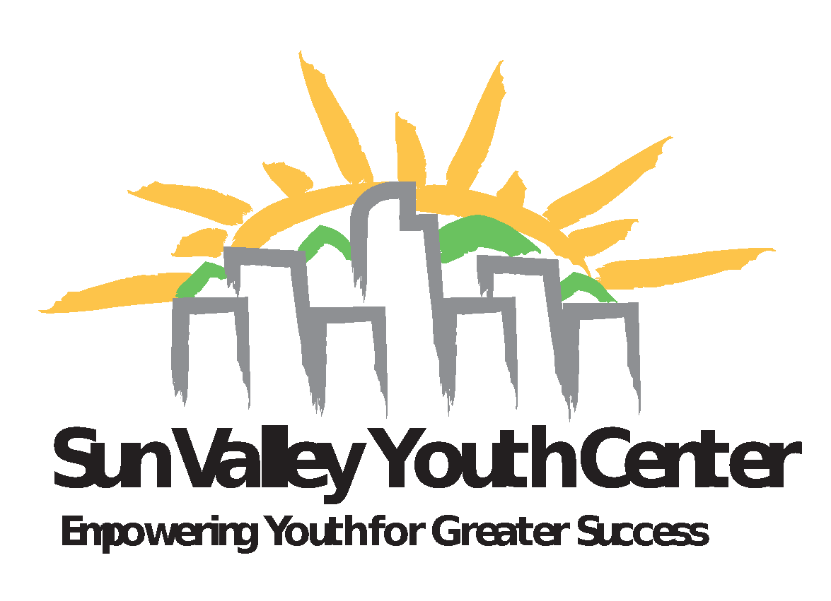

Have you ever been convicted of child abuse or neglect, or a crime that involved sexual contact with a minor?

YES NO

Has a complaint ever been filed against you in the context of employment or volunteer responsibility regarding sexual harassment or misconduct?

YES NO

*Please read the following carefully,* ***initial*** *by all policies you agree to adhere to, and sign below.*

### Waiver of Liability

____I understand that the Sun Valley Youth Center is not liable to provide insurance or workers compensation coverage to cover Sun Valley Youth Center volunteers who have been injured or become ill as a result of their volunteer work.

**Statement of Confidentiality**

_______The Sun Valley Youth Center has a legal and ethical responsibility to expect all participating parties to hold in confidence any information they become aware of during the course of their service. Any information, written, verbal or inferred, regarding a student or other participating member of the Sun Valley Youth Center will not be shared with persons outside of the program.

_______However, I understand that if, in the course of my service, I become aware of a case of sexual abuse, child abuse or neglect, be it on-going or having occurred in the past, that it is my duty to disclose any pertinent information to a staff member of the Sun Valley Youth Center immediately.

**Photography/Video/Story Rights Release**

_________I give the Sun Valley Youth Center and/or its affiliates, employees or agents the absolute and irrevocable right and permission to use photographs/videotape(s) taken of me in or outside of the agency alone or in the company of others, and to use the story of my experiences for the following reasons:

1. Any copyrighting that may be deemed appropriate.

2. Any use/re-use, publishing/re-publishing of the same in whole or in part, individually or in conjunction with other photographs/videotape(s) in any medium and for any purpose whatsoever, including but not limited to, illustration, promotion, and advertising and trade. I hereby release and discharge the Sun Valley Youth Center and its employees from any and all claims and demands, including but not limited to any and all claims for libel, invasion of privacy and breach of confidentiality, arising out of or in connection the use of negatives, slides, prints or videotapes taken of me by the Sun Valley Youth Center and/or the use of the story of my agency experience. By initialing this form, you agree that the Sun Valley Youth Center, its agents and employees have the right to use photographs taken of you and the story of your agency experience in any of its published materials or videotapes for a period of five years.

I, __________________________, am a volunteer tutor/mentor with the Sun Valley Youth Center. I have read the foregoing and agree to abide by any policy that I have left my initials next to.

___________________________________________ ___________________

Signature Date

___________________________________________ ____________________

Witnessed by Date